SOLANO COMMUNITY COLLEGE
MT 164, PROGRAMMABLE LOGIC CONTROLLERS
Spring, 2018

PLC PROGRAMMING LAB 4 - TIMERS & COUNTERS
Catharine Crayne
03/18/2018

OBJECTIVE
- To wire up and write a PLC Program that uses timers and counters.

GROUP MEMBERS
N/A

MATERIALS: Micrologix 1100 Trainer Unit, wires, RSLinx and RSLogix software, laptop, crossover cable.

SAFETY AND EQUIPMENT NOTES:
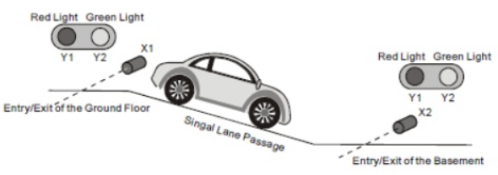
- Turn off trainer when attaching wires

PROCEDURE:
Parking Garage Scenario:
- Part 1: Cars pull into an underground parking lot and a series of lights control the passage of cars through a single lane. You’re contracted to wire up a PLC to control these lights and traffic so cars don’t collide through the single passage. The system has Red Lights and Green Lights as well as two beam break sensors that are NC when the beams are NOT broken. The owner wants the Red Lights on when a car is in the single lane passage, and Green when it is OK to enter. The system needs to start up initially with the Green lights on.
- Write a ladder logic program that meets the customer’s minimum requirements.
- Wire up a Micrologix Trainer to simulate the situation. Load your program and test it. Take a snapshot of your program and a picture of your test setup.
- Part 2: After a few weeks, your client requests some changes to be made. They request that a 3rd light (Lot Full Sign) flash on and off when the parking garage has 30 cars in it. Make a change to your program to accommodate the owner. Wire a 3rd light to the PLC trainer, load your program and test it. Take a snapshot of your program.
- BONUS CONTRACT OFFER: A couple of weeks later the owner is frustrated when a squirrel, bird, or trash blow past one of the beam break sensors and trips the system and the lights stay Red forever. They will pay you a nice bonus to fix this problem. Change your program to help them fix this.

RESULTS - DATA
Step 2: Snapshot of our program.

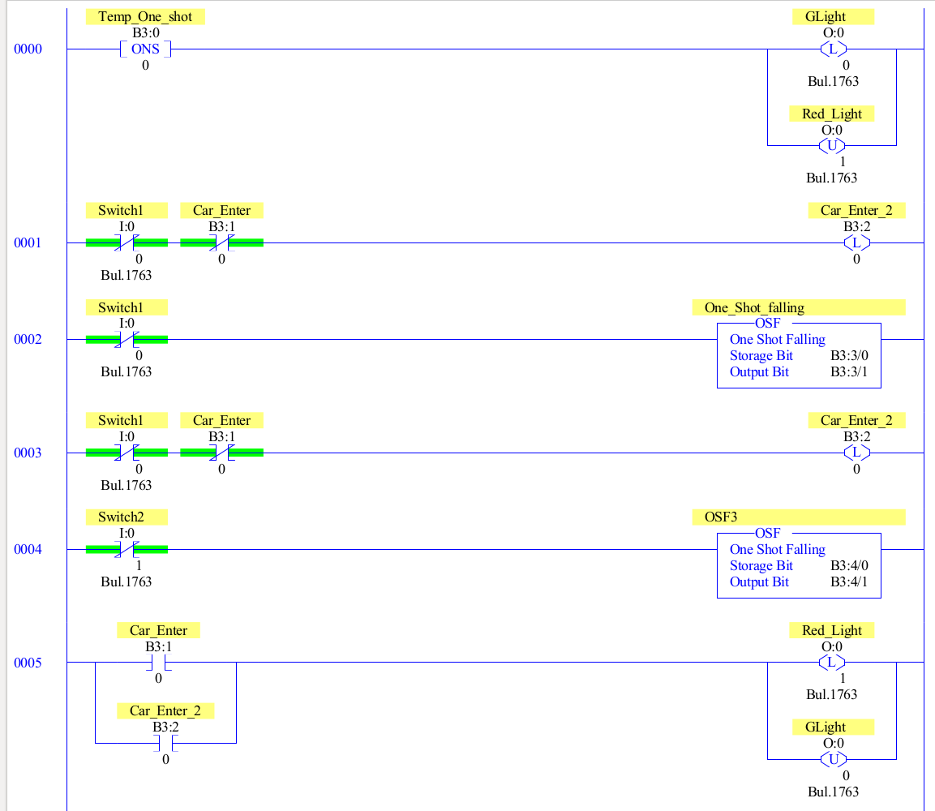

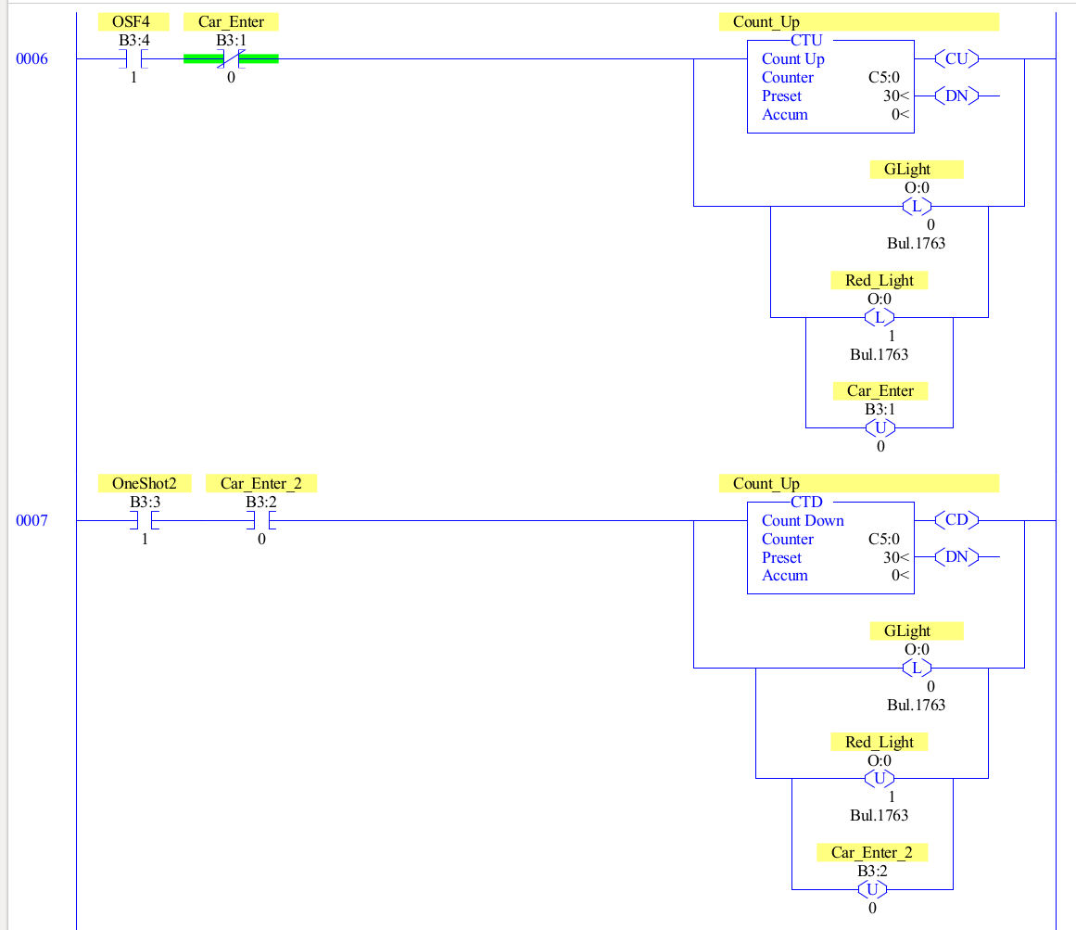

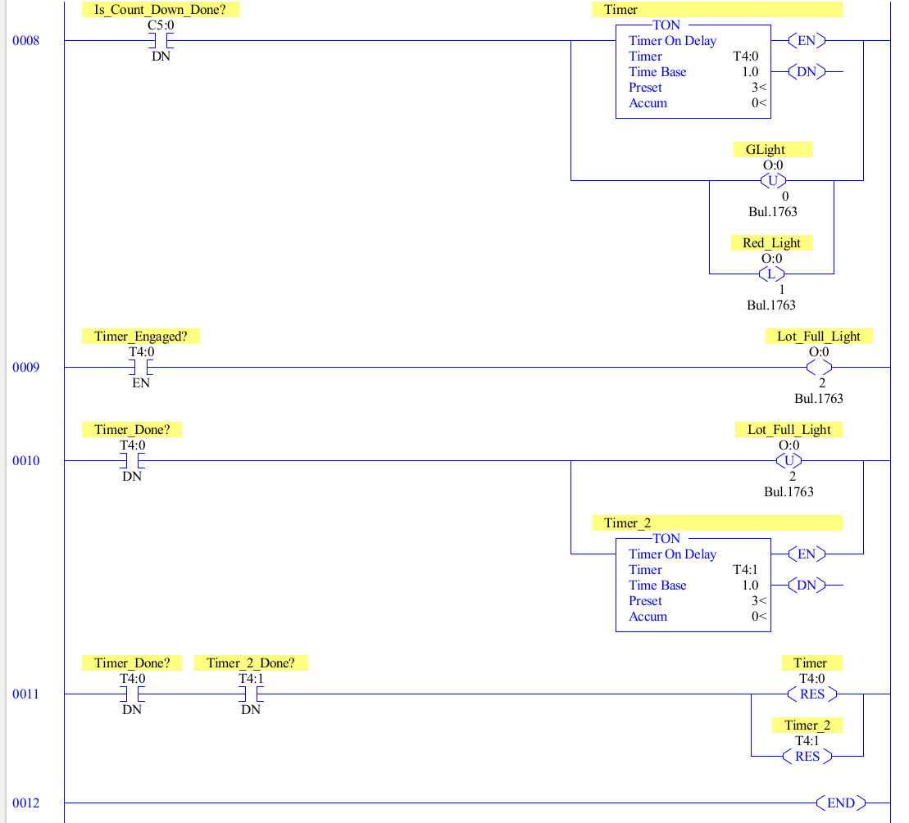

OBSERVATIONS
Step 1: Picture of our setup

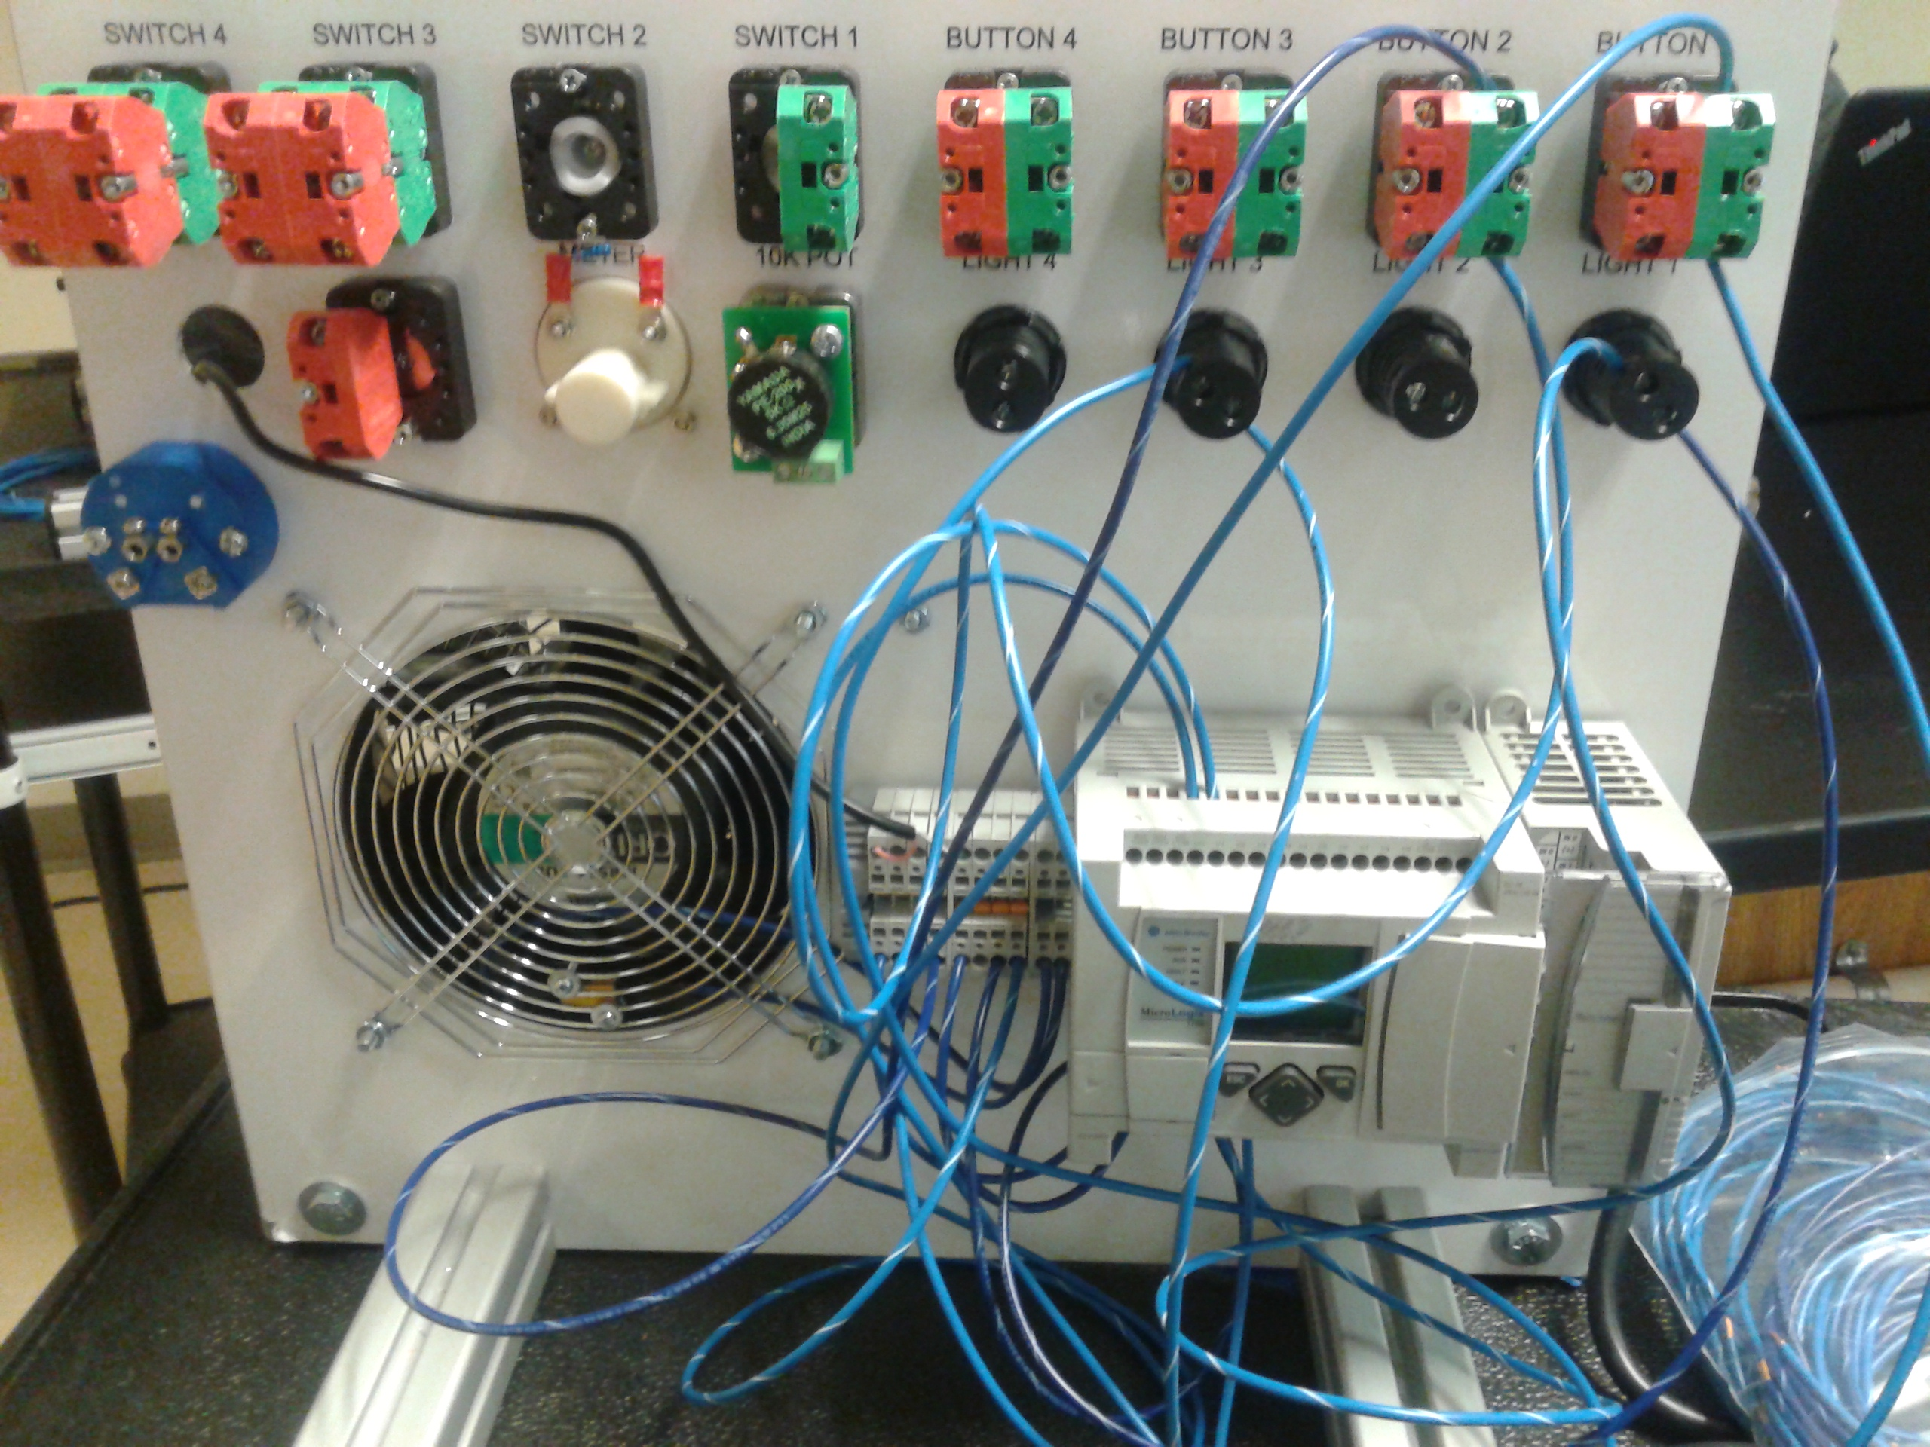

ANALYSIS QUESTIONS:
- What is the importance of using a latching control of the light when the system is first powered up?
-The purpose is to signal that a vehicle has not entered the parking garage.
- Look up Beam Break Sensors and find a model that can work directly with a PLC like the one used in class. Who makes it? What does it cost? What is it’s range? What type of light does the beam use?
-I looked at a photoelectric sensor from AutomationDirect, model number QMIHD-0N-0A. Each unit costs $59 USD. The range is 0-30 meters. It uses infrared light emission.
- How much memory do your programs use? Go to the “controller properties” to find out. What is the limit with these PLCs?
-The program has used 181 Instruction words and 74 Data table words. The total memory left is 6475 instruction words. The total memory availability of the PLC is 6730 words. There are 16 bits in a word, so a total of 4080 bits have been used. The PLC has a total of 107,680 bits of memory available.

